Rainbow Clock

Electronics

User’s manual

*Document Revision. B*

# Table of contents

Table of contents 1

Glossary 2

Product overview 3

1. Description 3

2. Capabilities 3

3. Quick specs 3

Basic operation 4

1. Reading the time of day 4

2. Changing the color scheme 4

3. Updating the time on the clock 4

Advanced operation 5

1. Synchronizing the clock using Bluetooth 5

Technical details 6

Planned features 9

Contributions 10

Endnotes 11

# Glossary

1. Microcontroller

An embedded computer integrating a whole range of peripherals in a small package for convenience.

1. Bluetooth

A wireless communication standard permitting short-range exchange of data between electronic devices.

1. Refresh rate

A measure of the number of times an image can be drawn completely over the period of a second; this value is expressed in Hertz. Synonymous to *“FPS”*.

# Product overview

## Description

Rainbow Clock is an unusual timekeeping device characterized by an exotic look and designed with electronics in mind.

## Capabilities

* Display the current time of the day
* Synchronize itself via a Bluetooth connection
* Alter its color scheme depending on events

## Quick specs

* Microcontroller: PIC32MZ series
* LEDs: 60, RGB type
* Refresh rate: ~10Hz
* Power: 15Watt max, 0.5Watt minimal, 0.6Watt typical (measured on a prototype)

# Basic operation

## Reading the time of day

Each color encodes a distinct time unit. For each unit:

* 3 red adjacent LEDs represent the hours.
* 2 green adjacent LEDs represent the minutes.
* The remaining blue LED represents the seconds.

To ease reading, the clock’s display is subdivided in four quadrants.

## Changing the color scheme

Using the central dial, navigate the menu looking for “Color Config.”

Validate your choice. You will be presented with a choice of colors on the screen. Use the dial again, select a color and validate your choice.

## Updating the time on the clock

Using the central dial, navigate the menu looking for “Time Config.”

Validate your choice.

# Advanced operation

## Synchronizing the clock using Bluetooth

Initiate a serial connection to the Rainbow Clock’s Bluetooth module configured for a rate of 115200 bauds. The code to be sent is structured as follows:

“T**ssmmhh**ddMMYYYY”

With ‘T’ designating the Time config function.

# Technical details

1. Block diagram



Buttons

(4 GPIO)

Buzzer

(PWM)



Bluetooth

Smartphone *

Raspberry Pi *

Bluetooth

Bluetooth

(UART)

LOGGING

(UART)

Light sensor (ADC)

LCD Display   
(11 GPIO)

Temperature and pressure sensor (SPI)

PIC32

AC to DC Power supply

1. Electrical consumption

* LEDs: Between 3.5V - 5.3V, about 60mA, 60mA x 60 = 3.6A max.
* PIC32: Between 2.3V - 3.6V, about 100mA.
* BMP280: Between 1.71V - 3.6V, about 4.2µA.
* RN4020: Between 3.0V – 3.6V, current is between 8mA 40mA.
* In line 3.3v the consumption of current is about 141mA, in line 5v current consumption is about 3.6mA maximum, the total consumption is 3.741A maximum.

1. Components required for the project

* 1 *(one)* PIC32xxxxxx microcontroller. Ref: xxxxxxx
* 1 *(one)* Strip of 60 RGB LEDs. Ref fab: WS2812b
* 1 *(one)* Incremental rotary encoder Ref: 1191733
* 1 *(one)* 20x4 alphanumeric LCD screen Ref: 2063162
* x *(xxx)* Resistors xΩ Ref: xxxxxxx
* x *(xxx)* Capacitors xF Ref: xxxxxxx
* 1 *(one)* Voltage regulator Ref: xxxxxxx
* 1 (one) Digital pressure and temp sensor Ref fab: BMP280
* 1 (one) Bluetooth communication module Ref: 2442930
* 1 (one) 5v Supply Ref: xxxxxxx
* 1 (one) Photocell Ref: 7482280
* 1 (one) buzzer Ref: 2361105
* 2 (two) push buttons Ref: 1550267

…

We decided to use WS2812b as our LEDs for their convenience (They can be driven with a single wire using a simple protocol described in the datasheet of the component). (Not going to be bought from Farnell)

For our sensor, we chose the BMP280 or the BME280. It provides both temperature / pressure measurements and uses the I²C protocol. (Not going to be bought from Farnell).

A photoresistor will be used in a voltage divider setup, connected as an analog input pin.

[courbe de tendance ] lux en function de la tension recue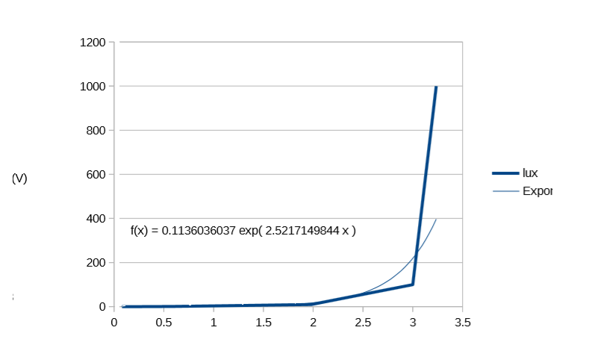

We chose a rotary button for most of the interfacing with the clock. On the plus side, any watch user will figure out its multiples purposes.

Uses 2 gpio + 2 others buttons 2gpio.

We want to use a “Serial to Bluetooth” module for the device to communicate with smartphones and computers, so as to avoid the potential complexity of implementing a full Bluetooth stack, which we can’t afford at this time.

UART is a communication protocol, uses a trame we have to use a same speed between PIC and Bluetooth we have choose 115200 bauds, in 8 bits mode, 1 Bit for stop.

The chosen power supply can deliver up to 4A at 5v, and will still support the charge with all LED set at their maximum brightness level.

The chosen voltage regulator can deliver up to 1A in 3.3v for electronic modules using this amount of voltage.

# Planned features

* ***Display basic weather data and forecast using built-in sensors***

Data gathering could reveal itself being a nice addition to the project.

# Contributions

In alphabetical order:

* **ltesson** ltesson@student.42.fr
* **nahmed-h** nahmed-h@student.42.fr
* **schiad** schiad@student.42.fr
* **vchesnea** vchesnea@student.42.fr

*Page layout by:* vchesnea

# Endnotes